* **Gold plating: Hard Gold & Soft Gold:**

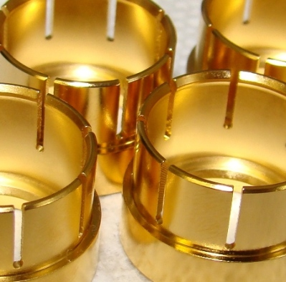

* **Electrolytic Nickel Sulfamate Plating:**

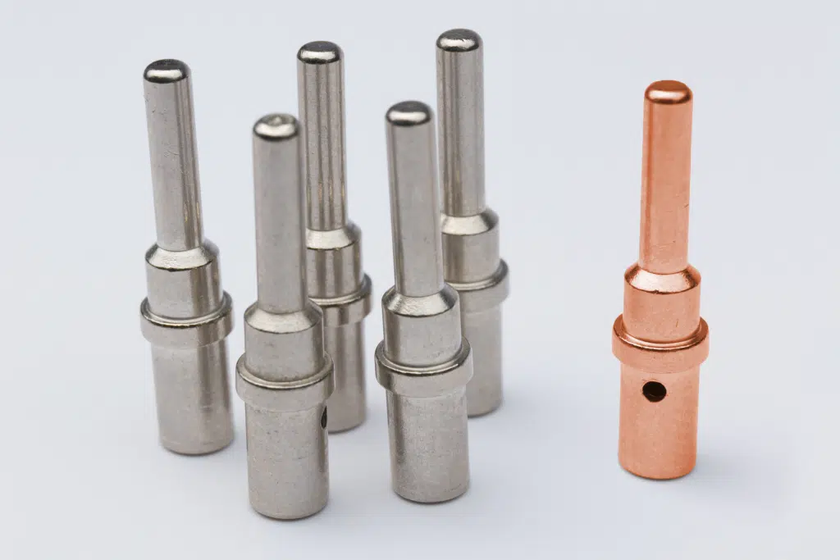

* **Electroless Nickel:**

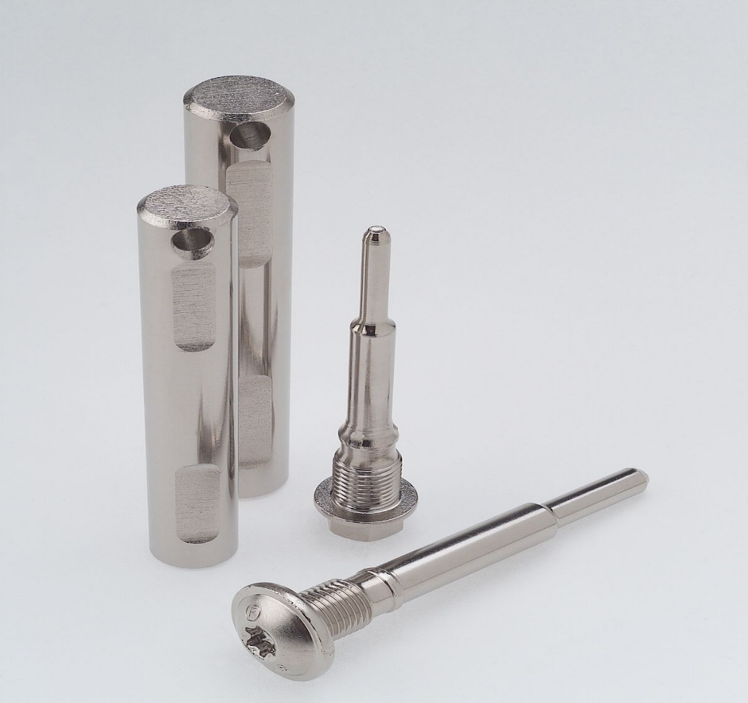

* **HASL (Hot air Leveling):**

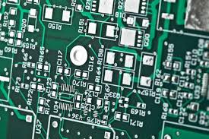

* **Immersion White Tin Plating:**

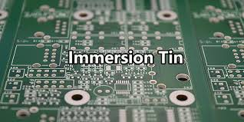

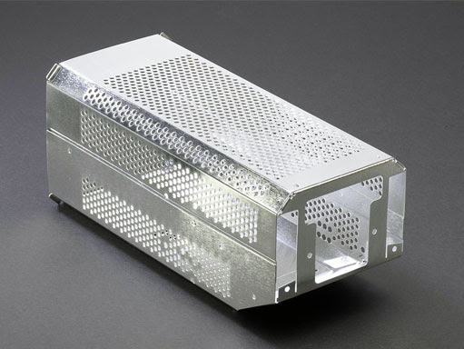

* **Organic solderability protectant (OSP):**

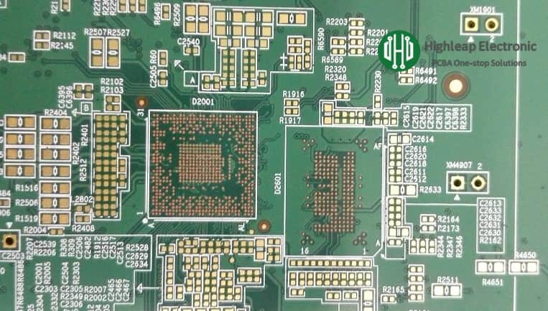

* **Silver plating:**

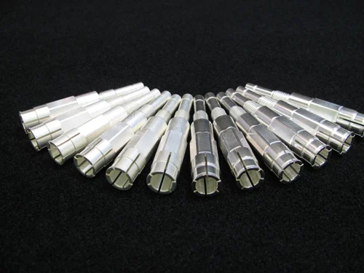

* **Passivation:**

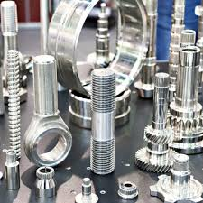

* **Copper Plating:**

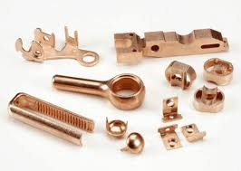

* **Chemical Film Specifications (Non-RoHS) & (RoHS) Plating:**

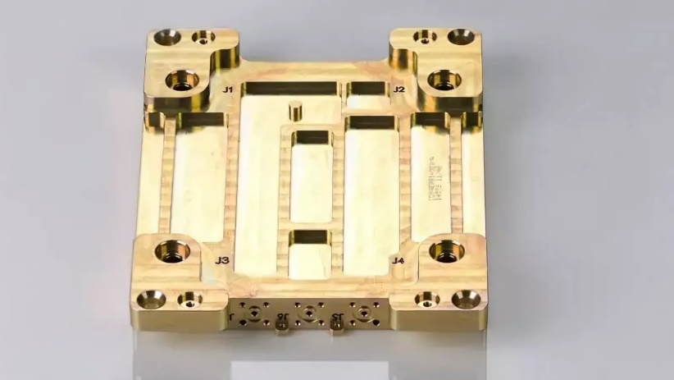

* **Alodine, IRIDITE, chem-film refers to a chemical conversion coating & Clear, protective, tarnish-resistant chromate film on silver:**

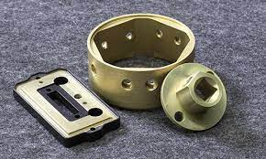

* **Solder Mask Striping**

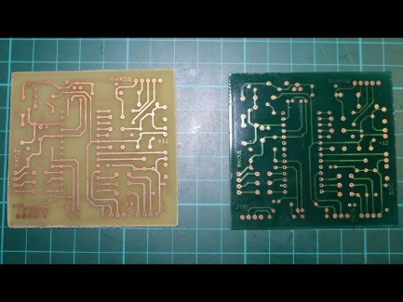

* **Electroless Nickel Striping**

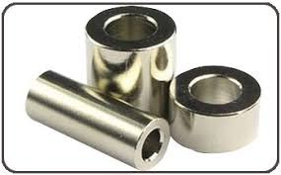

* **Gold Striping**

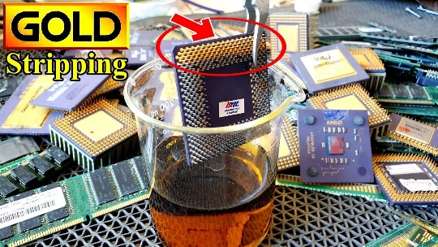

* **X-Ray thickness Report**

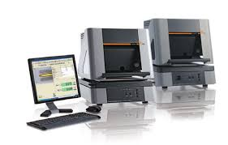

* **Cross Section**

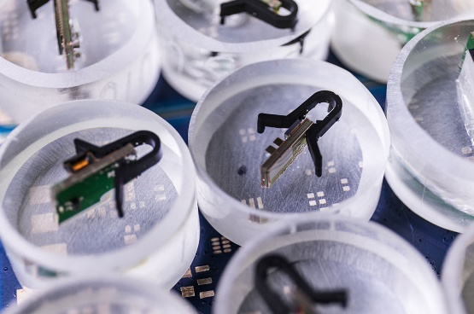

* **Gold brush plating**

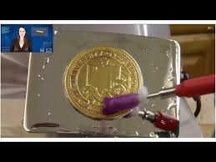

* **Nickel brush Plating**

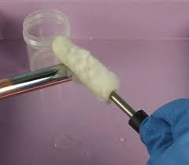

* **Barrel Plating**

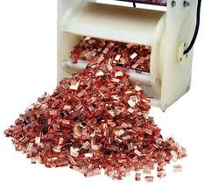

* **Bead Blasting**

